**INFLUENCE OF ROOF EAVE DEPTHS ON INDOOR AIR TEMPERATURE REDUCTION FOR THERMAL COMFORT OF AN OFFICE BUILDING IN NASARAWA, NIGERIA.**

**Muhammed Gambo Abdullahi1, Joseph Awoamin Yacin2, Umar Yusuf1\***

1School of Environmental Studies, Department of Architectural Technology, Federal Polytechnic Nasarawa, P.M.B. Nasarawa, Nasarawa State,

2School of Environmental Studies, Department of Estate Management and Valuation, Federal Polytechnic Nasarawa, P.M.B. Nasarawa, Nasarawa State,

3*School of Environmental Studies, Department of Survey and Geoinformatic, Federal Polytechnic Nasarawa, P.M.B. 1 Nasarawa, Nasarawa State,

*Corresponding Author: ***gamspeco@yahoo.co.uk***

**Abstract**

***INTRODUCTION/BACKGROUND****-Air temperature reduction is one of the paramount practices to improving room thermal comfort, thereby reducing the cost of cooling during the heat period of a place. Various innovative exterior shadings are architectural necessity to cut down cost of cooling in building as they prevent building envelop from being heated by solar radiation. So many shading strategies in previous studies were investigated but uncommon among them is roof-eave projections.* ***AIM/OBJECTIVE(S)****-It is on this background that, this paper aimed at determining the extent of thermal discomfort reduction by the use of different roof-eaves’ depths (0.6m, 1.2m and 1.8m) via decrease in the high air temperature experienced in February to May in Nasarawa.* ***METHODOLOGY****-The methodology adopted in this paper is computer simulation known as integrated environmental solution-virtual environment (IES-VE). The IES-VE was subjected to examine the degree of thermal performance of the extended eaves via air temperature reduction as this have direct effect on the indoor comfort of a build.* ***RESEARCH FINDINGS****-The varied roof-eave depths have shown air temperature reduction to enhance thermal comfort of the indoor condition as R60, R120 and R180 roof-eave types depths lowered the average temperature by 1.5°C, 2.7°C and 3.1°C respectively when compared with the R00 roof-eave type. Therefore, extension of roof-eaves has a huge advantage of diminishing the effect of solar heat transmission into Nasarawa buildings in Nigeria hot climate season.* ***RECOMMENDATION****-The study recommended that further study should be conducted in consideration of building height vis-a-vis the roof eaves.*

***KEYWORDS****:* Indoor Air Temperature, Roof Eave Depths, Thermal Comfort, Office Buildings, Bioclimatic Design

1.0 **Introduction**

As the menace of climate change continuing to soar global temperature leading to high demand of cooling and heating energy for building operations, environmental stakeholders such as architects, town planners, engineers, builders and the like are expected to play their role to mitigating this effect for better habitable environment. For an architect, one of the strategies to achieving environmental comfort in buildings is the use of passive and bioclimatic design. This strategy was emphasized by Elaouzy & El Fadar, (2022) that, Bioclimatic and passive design strategies are proficient architectural methods to improving thermal comfort, lower energy consumption and diminish the carbon footprint of buildings.

Air temperature reduction is one of the paramount practices to improving room thermal comfort, thereby reducing the cost of cooling during the heat period of a place like Nasarawa in Nigeria. This act also reduces the amount of greenhouse gases release to atmosphere causing global warming leading to climate change. This exercise also lessened the carbon foot print which conformed to the environmental sustainable development strategies…

**2.0 Review of Previous Studies**

Previously, studies have been carried out on building design strategies in reducing air temperature in indoor space for thermal comfort. Most of these studies focus mostly on shading strategies through orientations (Tong, et al., 2021; Al-Absi, et al., 2020; Csáky & Kalmár, 2015), material applications (Al-Absi, et al., 2020; Ekoe et al., 2015; Shen, et al., 2011), building forms (Magri et al., 2021), fenestration or window design (Tong, et al., 2021), recessed wall façade (Abdullahi, et al., 2022) and active cooling. As for particular studies on roof eaves, Hassan, (2010) applies attached roof-eave strategy of 1.0m and found its shading ability. The study of “Vernacular Architecture of South Asia: Exploring Passive Design Strategies of Traditional Houses in Warm Humid Climate of Bangladesh and Sri Lanka” by Ratree, (2020, May) revealed the shading provided by roof-eave by protecting the wall from solar penetration from outdoor environment. Other previous studies (Wu, et al., 2020; Bougiatioti & Oikonomou, 2017; Madhumathi, et al., 2014; Sun, 2013) mentioned the performance of roof-eaves in providing shade for energy efficiency and passive design options. A study by Bekkouche, et al., (2011) was particularly about roof-eave, thermal insulation, proper orientation and indoor air temperature control. The study recommended that, for better thermal comfort, there should be introduction of roof-eaves into building for shading. However, most of these studies lack information about their effect on indoor air temperature, particularly when considering the various depths of the roof-eave...

**3.0 The Study Area and its Climatic Condition**

Nasarawa Local Government Area is located in the North-Central part of Nigeria at latitude 8.53895º (8º32’) N and longitude 7.70821º (7º.42’) E. The climate is characterized by high temperatures and low humidity in the dry season. The daily temperature varies from an average daily maximum of 34.7ºC to a daily minimum of 19.1ºC. The mean relative humidity is highest in August (80.5%) and lowest in March (22.5%). The mean annual rainfall is over 800mm per annum in the southern part and only 500mm per annum in the extreme north. The hot dry season occurs between March-June, while the rainy season is between July-September. The hottest month in Nasarawa is March with 40.5ºC, while the coldest months are December and January, with 13.1ºC and 12ºC respectively.

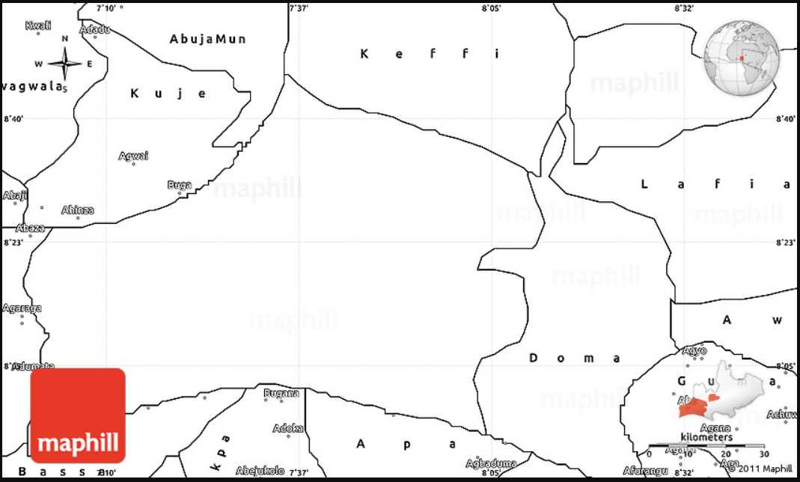

**Figure 1.** Map of Nasarawa Nigeria. (Source: [https://www.worldmap1.com/map/northern-Nigeria/Nasarawa-map.asp](https://www.worldmap1.com/map/northern-cyprus/lefkosa-map.asp))

**4.0 Methodology**

The methodology used in this paper is computer simulation. This is one of the reputable methodology involving the investigation of building physics to ascertain it bioclimatic level and building performance (Zheng, et al., 2022; Moolavi et al., 2021). Building physics design configuration and materials used can affect the bioclimatic expectation of any buildings. In this paper, extension of building eave to play the function of a shading component of an office building was tested at different depths using a trusted and tested simulation software known as integrated environmental solution-virtual environment (IES-VE). The IES-VE was subjected to examine the degree of thermal performance of the extended eaves via air temperature reduction as this have direct effect on the indoor comfort of a building (Ozarisoy, & Altan, 2021).

In achieving the precision of any simulation, the best practices known as calibration (Al-Tamimi, & Fadzil, 2011) have been shown in the literature that the measured results must be compared with the simulated results (Abdullahi, et al., 2022; Al-Tamimi, & Fadzil, 2011) to show how a real live situation can be equated or represented with the virtual environment. In this case, components and the design configurations of the real model must be imputed into the virtual model(s) during the setup of the simulation software (Abdullahi, et al., 2022).

In calibrating building simulation, the experimental field result is compared with that of the computer software (IES-VE) simulated. The methodology was completed using three stages. Stage one has to do with collection data from the experimental field work. The second stage is the validation to know the viability and reliability of the software through comparing the simulated result and the field measured air temperature data. This comparison was deduced by percentage difference (PD) used by Vangimalla, et al. (2009) and Abdullahi, et al. (2022) despite several statistical measured available because of the ease of computation of PD.

The

|  |  |
| --- | --- |
| PD = $\frac{(B-A)}{A}X100$ | (1) |

PD = percentage difference (%), A = Measured value, and B = simulated value.

**Table 1:** Classification of thermal condition of an environment (National Weather Service, 2016; Abdullahi, et al., 2016)

|  |  |  |
| --- | --- | --- |
| Classification | Heat index (oC) | Effect on the body |
| Acceptable | 24 – 26.7°C | Comfortable |
| Caution | 26.7 – 32.2°C | Fatigue |
| Extreme Caution | 32.2 – 39.4°C | Heat stroke, cramps or exhaustion |
| Danger | 39.4 – 51.1°C | Heat cramps and heat exhaustion |
| Extreme Danger | 51.7°C and above | Heat stroke |

**5.0 Results and Discussion**

After validating the software (IES-VE), a building performance simulation was conducted to investigate the various depths of roof-eaves. This exercise was carried out using four (4) models, one without the roof-eave (0.0m or R00) depth projection and the other three with R60, R120 and R180 roof-eaves of 0.6m, 1.2m and 1.8m depths respectively. The hottest 3.4 months maximum, average and minimum air temperature was assessed and compared with the zero projected roof-eave under same conditions. Simulation results are shown in Figure 1 below with the period range results of all the models.

From the Figure 1, it reveals the different performance of roof-eaves with different depths considering the maximum, minimum and average air temperature of the hot period of Nasarawa Nigeria. As Shading strategies have general impact on the climate of Nigeria and Mediterranean region (Al-Din, et al.,. 2017), the performance indicate the shading ability of roof-eaves with varied depths. The overall results showed that roof-eave with 1.8m depth has a significant effect in lowering the indoor air temperature in the hot period of Nasarawa Nigeria. The investigation also revealed that roof-eave projection has the impact of decreasing indoor air temperature of a building as all the roof-eaves (0.6m, 1.2m and 1.8m) play a part in reducing indoor air temperature. The Figure 1 clearly indicate that, the hot period of 3.4 months maximum indoor air temperature reduction of 2.9°C was realized by applying roof-eave of 1.8m depth on a bared or zero roof-eave façade. Similarly, the hot period average and minimum indoor air temperature reduction of 3.1°C and 2.2°C was achieved by applying roof-eave of 1.8m on a zero roof-eave façade respectively.

**Figure 5.** Influence of Roof-eaves depths on air temperature reduction

**6.0 Conclusion and Recommendation**

Various innovative exterior shadings are architectural necessity to cut down cost of cooling in building as they prevent building envelop from being heated by solar radiation. So many shading strategies in previous studies were investigated but uncommon among them is roof-eave projections. This type of projection has shown a significant effect on enhancing the thermal condition of an indoor environment. However, higher projection of roof-eaves (R180) have shown better shading impact in reducing air temperature of an indoor space. Roof generally functions as building envelop cover and it extension or projection provides window shading that block the solar radiation which invariably avoid the effect of solar incidence on building fenestrations. The varied roof-eave depths have shown air temperature reduction to enhance thermal comfort of the indoor condition as R60, R120 and R180 depths lowered the average temperature by 1.5°C, 2.7°C and 3.1°C respectively when compared with the R00 roof-eave type. Therefore, extension of roof-eaves has a huge advantage of lessening the effect of solar heat transmission into Nasarawa buildings in Nigeria hot climate seasons.

**7.0 Acknowledgement**

The authors acknowledge the financial and material support of the Nigerian Tertiary Education Trust Fund (TETFund) and Federal Polytechnic Nasarawa, Nigeria. Many thanks also to Universiti Teknologi Malaysia for providing an enabling environment conducive to learning and research.

**8.0 References**

Abdallah, A. S. H., Hussein, S. W., & Nayel, M. (2020). The impact of outdoor shading strategies on student thermal comfort in open spaces between education buildings. Sustainable Cities and Society, 58, 102124.

Abdullahi, M. G., Kandar, M. Z. B., Wah, L. Y., & Joseph, A. (2016). Perspectives on heat index and climate change on thermal comfort and human health. Int J Sci Res Sci Eng Technol, 2(4), 7-14.

Abdullahi, M. G., Ojobo, H., Sani, M., Naibi, A. U., Chukwuma-uchegbu, M. I., & Aliero, M. S. (2022). Validating integrated environmental solutions software for air temperature of a typical Malaysian recessed wall façade office building. Journal of Civil Engineering and Environmental Sciences, 8(1), 031-040.

Al-Din, S. S. M., Iranfare, M., & Surchi, Z. N. S. (2017). Building thermal comfort based on envelope development: criteria for selecting right case study in Kyrenia-North Nigeria. *Energy Procedia*, *115*, 80-91.

Al-Absi, Z. A., Hafizal, M. I. M., Ismail, M., Mardiana, A., & Ghazali, A. (2020). Peak indoor air temperature reduction for buildings in hot-humid climate using phase change materials. Case Studies in Thermal Engineering, 22, 100762.

Al-Din, S. S. M., Iranfare, M., & Surchi, Z. N. S. (2017). Building thermal comfort based on envelope development: criteria for selecting right case study in Kyrenia-North Nigeria. Energy Procedia, 115, 80-91.